The Moss Growth Optimization (MGO):

Concepts and performance
Boli Zheng¹, Yi Chen¹, Chaofan Wang¹, Ali Asghar Heidari², Lei Liu³ and Huiling Chen^{1, *}

¹ Key Laboratory of Intelligent Informatics for Safety & Emergency of Zhejiang Province, Wenzhou University, Wenzhou 325035, China
² School of Surveying and Geospatial Engineering, College of Engineering, University of Tehran, Tehran, Iran
³ College of Computer Science, Sichuan University, Chengdu, Sichuan 610065, China
∗ Corresponding author. chenhuiling.jlu@gmail.com

Abstract
The moss growth optimization (MGO), introduced in this paper, is an algorithm inspired by the moss growth in the natural environment. The MGO algorithm initially determines the evolutionary direction of the population through a mechanism called the determination of wind direction, which employs a method of partitioning the population. Meanwhile, drawing inspiration from the asexual reproduction, sexual reproduction, and vegetative reproduction of moss, two novel search strategies, namely spore dispersal search and dual propagation search, are proposed for exploration and exploitation, respectively. Finally, the cryptobiosis mechanism alters the traditional metaheuristic algorithm's approach of directly modifying individuals' solutions, preventing the algorithm from getting trapped in local optima. In experiments, a thorough investigation is undertaken on the characteristics, parameters, and time cost of the MGO algorithm to enhance the understanding of MGO. Subsequently, MGO is compared with ten original and advanced CEC 2017 and CEC 2022 algorithms to verify its performance advantages. Lastly, this paper applies MGO to four real-world engineering problems to validate its effectiveness and superiority in practical scenarios. The results demonstrate that MGO is a promising algorithm for tackling real challenges. The source codes of the MGO are available at https://aliasgharheidari.com/MGO.html and other websites.
Keywords: Metaheuristic; Optimization; Swarm intelligence; Moss growth optimization; Engineering design problems

Moss growth optimization
This section will initially introduce the source of inspiration derived from moss and subsequently introduce the mathematical models of the algorithm.

Inspired from moss
Moss is one of the oldest types of land plants on Earth (Heckman et al., 2001). It commonly thrives in damp and shaded locales; nevertheless, it demonstrates resilience in diverse settings, ranging from wooded areas to metropolitan regions (Schaefer & Zrÿd, 2001). Although lacking flowers, fruits, seeds, roots, or true vasculature (Lueth & Reski, 2023), this plant relies on distinctive mechanisms for reproduction. Specifically, they have three modes of reproduction: asexual, sexual, and vegetative. Additionally, cryptobiosis serves as a critical survival strategy that contributes to the perpetuation of the species.
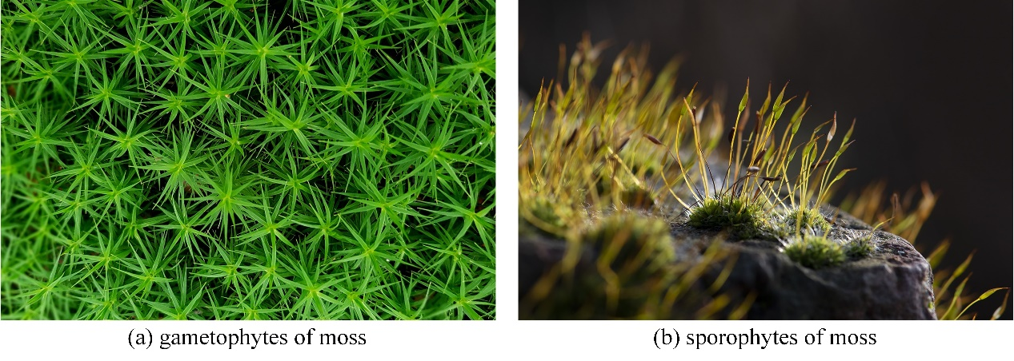
Figure 1. Different stages of moss.
Moss exhibits a peculiar phenomenon known as heteromorphic alternation of generations, whereby the sporophyte and gametophyte stages alternate (Cove, 2005; Reski, 1998), as shown in Figure 1. Sporophytes of moss release spores, which subsequently develop into new moss individuals called the gametophytes. This process coincides with asexual reproduction in moss. Moss spores are mainly released in the morning when wind speeds are relatively low (Johansson et al., 2016). Furthermore, spores released under stable wind conditions in the morning tend to travel more distances than those dispersed later in the day under more turbulent winds. This suggests that morning winds provide more favorable conditions for spore dispersal. Figure 2 demonstrates the dispersal of spores in stable and turbulent winds. Figure 2a illustrates that the spores exhibit a consistent trajectory and disperse over long distances in stable winds. Conversely, Figure 2b demonstrates that spores display erratic trajectories and disperse only over short distances in turbulent winds.
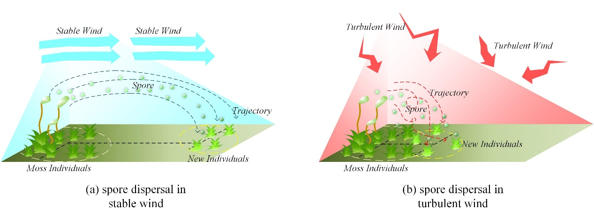
Figure 2. Dispersal of spores in stable and turbulent winds.
Sexual reproduction of moss requires free-motile sperm to travel from male to female gametophytes (Rosenstiel et al., 2012). When the sperm, aided by water droplets present on the moss, attach to the eggs and fertilize them, they form zygotes. These zygotes further develop into the sporophytes of moss. The sporophyte depends on the gametophyte for nourishment and remains attached to it. Simultaneously, gametophytes that inhabit more favorable surroundings are inclined to yield sporophytes (Johnson & Shaw, 2016). The phenomenon of sporophyte growth is visually depicted in Figure 3. It is assumed that as one moves closer to the center of the depicted figure, the environmental conditions become more suitable for moss. Hence, the moss at the center is more inclined to foster sporophytes. In addition, gametophytes can contribute genes to sporophytes when produced through sexual reproduction.
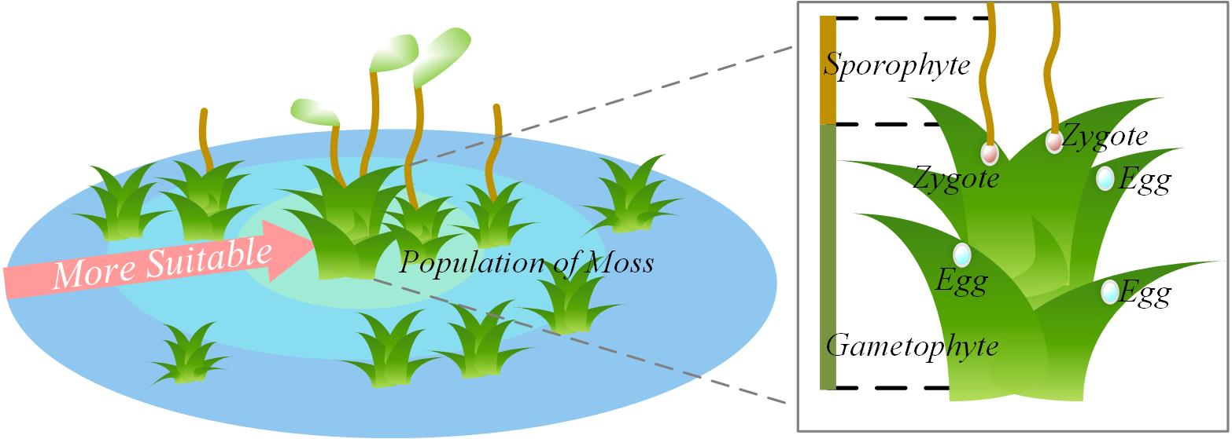
Figure 3. Growth of sporophytes.
The regeneration of vegetative material is common in many moss species, with some shedding fragments that can form the basis of new individuals (Lueth & Reski, 2023). Figure 4 illustrates that shedding fragments of moss are dispersed to various locations through the influence of wind, where they subsequently develop into new individuals. Notably, the dispersal of fragments tends to be more localized than the dispersal of spores.
Cryptobiosis refers to a state of life that is reversible ametabolic, distinguished by the cessation of all metabolic processes (Cannone et al., 2017). This peculiar state enables mosses to endure periods of highly challenging conditions. Furthermore, mosses possess the capacity to revive when conditions become suitable again.
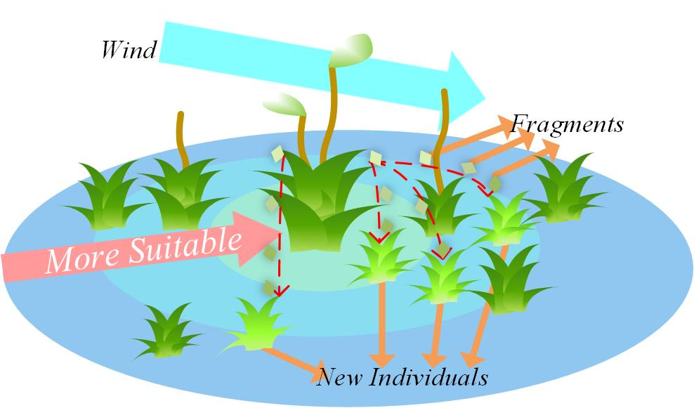
Figure 4. Vegetative reproduction.
In summary, this paper is inspired by the growth mechanism of moss and proposes a useful algorithm named the MGO method. This algorithm incorporates a spore dispersal search for global search space exploration. Subsequently, a dual propagation search is introduced to facilitate local exploitation, which simulates both sexual reproduction and vegetative reproduction. Lastly, a cryptobiosis mechanism is presented as an improved greedy selection mechanism.

Mathematical model and optimization algorithm
In this section, based on the growth model formulated by moss, this paper first presents the four key stages: determination of wind direction, spore dispersal search, dual propagation search, and cryptobiosis mechanism. Among them, determining wind direction is the most critical mechanism, and it decides the evolutionary direction of the population. Subsequently, we introduce the MGO algorithm.

Determination of wind direction
The growth of moss is influenced by the presence of wind, primarily due to the crucial role wind plays in the dispersal of spores. Due to the significance of wind direction, MGO has developed a creative mechanism called "determination of wind direction." This mechanism utilizes the position relationship between most individuals and the optimal individual to determine the evolutionary direction of all individuals in the population. This evolutionary direction effectively helps MGO avoid trapping into local optimum solutions. It should be noted that the MGO algorithm considers a single moss individual as a search agent $M$. The algorithm's population $X$ is comprised of all moss individuals. In this paper, to emulate the wind direction by relying on the following assumptions made by the MGO algorithm:
- The wind direction remains constant throughout an entire iteration.
- Assuming that moss individuals represent the positions within the solution space, the current best candidate position corresponds to the current moss individual in the optimal solution.
- The direction of the wind always blows from areas with a higher quantity of moss towards the individual moss in the most favorable growth environment.
The most exceptional individual within the population $X$ is $M_{best}$. This paper employs the j-dimensional value of $M_{best}$ as a threshold and compare the j-dimensional values of all individuals with it. Based on this comparison, $DX_{j1}=\{M_{i}=\left(M_{i,1},M_{i,2},...,M_{i,dim}\right)∨M_{i,j}≥M_{best,j},M_{i}∈X\}$ and $DX_{j2}=\{M_{i}=\left(M_{i,1},M_{i,2},...,M_{i,dim}\right)∨M_{i,j}<M_{best,j},M_{i}∈X\}$ are partitioned, where $M_{i,j}$ is the j-th particle of the i-th moss individual, and $dim$ is the dimension of moss individual. Then, the set with the larger number of members is selected, as illustrated in Eq. (1).
 | $${divX}_{j}=\left\{\begin{matrix}{DX}_{j1}, & count\left({DX}_{j1}\right)≥count\left({DX}_{j2}\right) \\ {DX}_{j2}, & count\left({DX}_{j1}\right)<count\left({DX}_{j2}\right)\end{matrix}\right.$$ | (1)
where function indicates calculating the quantity of moss individuals in a given collection of sets.
For sets acquired subsequent to numerous divisions, refer to Eq. (2).
 | $$diνX=\{M_{i}=\left(M_{i,1},M_{i,2},...,M_{i,dim}\right)|M_{i}∈j=1dndiνX_{p_{j}},M_{i}∈X\}$$ | (2)
where $dn$ denotes the number of times to be divided, and in this paper the value of $dn$ is set to $⌊{dim}/4⌋$ and is not less than 1. $⌊·⌋$ denotes the floor function of the enclosed number. $p_{j}$ represents the j-th random number, conforming to a range $\left(1,2,…,dim\right)$, and satisfies Eq. (3).
 | $$j=1dnp_{j}=∅$$ | (3)
In this paper, a brief simulation of the wind is performed, where the wind always comes from the region $divX$ to the most exceptional individual $M_{best}$, as illustrated in Figure 5. The precise computation of the wind's direction is demonstrated in Eq. (4).
 | $$D_{−wind=\frac{1}{num}\sum_{i=1}^{mum}{}{dM}_{i},{dM}_{i}∈dirX}$$ | (4)
where $D_{wind}$ represents the calculated wind direction, which has the same dimension as the individuals. The variable $num$ indicates the total number of individuals in the $dirX$. The calculation of $dirX$ can be observed in Eq. (5). The reason for calculating the mean distance between major individuals and $M_{best}$ is that this method can help smooth the path of individuals approaching $M_{best}$, thereby enhancing the optimization ability of MGO.
 | $$dirX=\{M_{best}−M_{i}∨M_{i}∈divX\}$$ | (5)
where $dirX$ denotes the collection of distances that separate individuals within the $divX$ with respect to $M_{best}$.
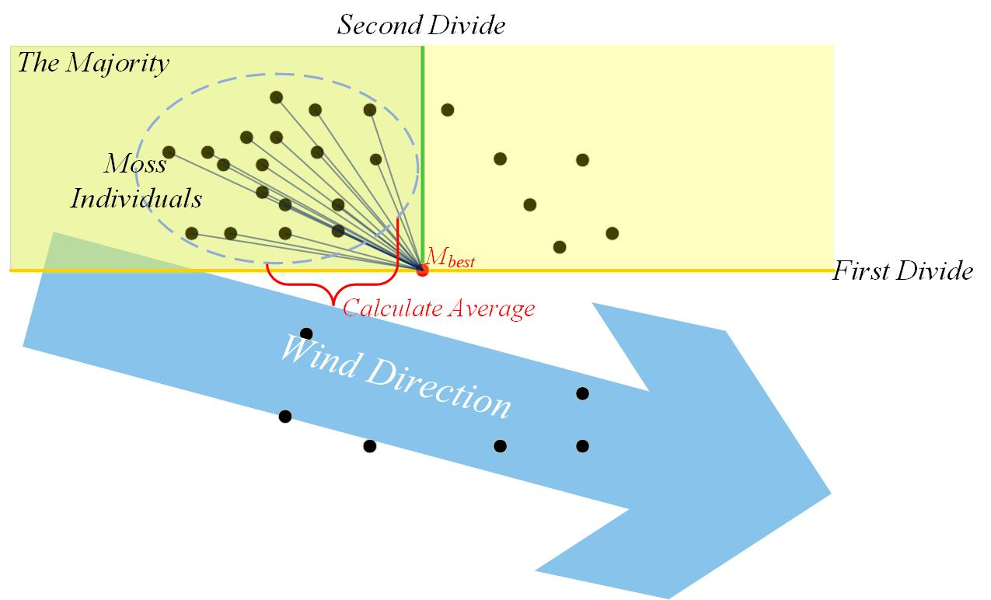
Figure 5. The process of wind direction.

Spore dispersal search
The exploration phase of the MGO involves the spore dispersal search. In situations where there is a significant presence of wind, the dispersal of spores occurs in a highly unpredictable manner, resulting in a substantial transmission distance. Under stable wind conditions, spores are capable of traveling a greater distance, whereas under turbulent conditions, they tend to disperse over shorter distances. The majority of spores are dispersed in stable wind conditions, while a minor portion disperses during turbulent conditions. Ultimately, as wind strength diminishes, spores begin to settle in closer proximity to the moss.
In this paper, the position of spores is considered a new solution. Modeling is conducted to simulate the dispersal characteristics of spores through wind, as shown in Figure 6. The position of spores is determined in Eq. (6). The difference in the size of the two steps is significant. This allows individuals to make random choices to prevent fixed step lengths from causing slow convergence in the early stages of failure to converge in the later stages, ensuring population diversity.
(6)
where $M_{i}^{new}$ denotes a novel moss that is acquired through the dispersal of spores from i-th moss individual $M_{i}$. $r_{1}$ is a random number in the range $\left(0,1\right)$, while $d_{1}$ is a constant parameter that is set to 0.2 in this paper. If $r_{1}>d_{1}$, Spores disperse under stable wind conditions, whereas they disperse under turbulent conditions. $step1$ represents the distance of spore dispersal in stable wind conditions, as shown in Eq. (7). $step2$ represents the distance of spore dispersal in turbulent wind conditions, as shown in Eq. (8).
 | $$step1=w·\left(r_{2}−0.5\right)·E$$ | (7)
where $w$ is a constant parameter that is set to 2 in this paper. $r_{2}$ is a random vector in the range $\left(0,1\right)$, which has the same dimension as $D_{wind}$. $E$ is the strength of wind, which diminishes as the iterations progress, as shown in Eq. (9).
 | $$step2=0.1⋅w⋅\left(r_{3}−0.5\right)⋅E⋅\left[1+\frac{E}{2}⋅\left(1+tanh⁡β\sqrt{1−β^{2}}\right)\right]$$ | (8)
where $r_{3}$ is a random vector in the range $\left(0,1\right)$, which has the same dimension as $D_{wind}$. The values for $β$ is shown in Eq. (10).
 | $$E=1−\frac{FEs}{MaxFEs}$$ | (9)
where $FEs$ denotes the present count of evaluations, while $MaxFEs$ signifies the maximum number of iterations.
 | $$β=\frac{count\left(divX\right)}{count\left(X\right)}$$ | (10)
where $β$ represents the proportion of the population in $divX$ to the population in $X$.
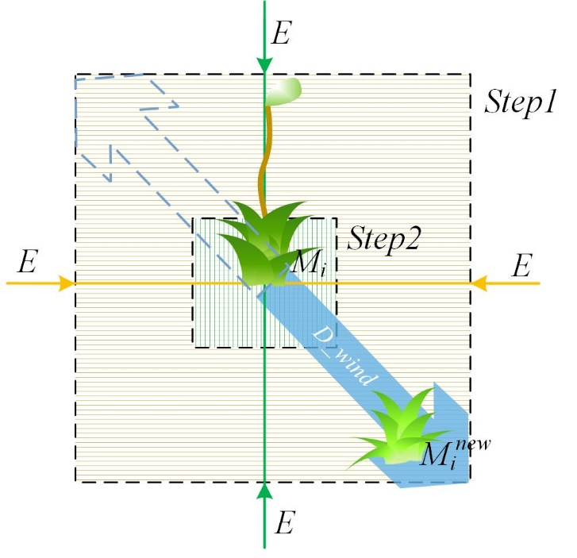
Figure 6. Search process of spore dispersal search.

Dual propagation search
The exploitation phase of the MGO involves the dual propagation search, which simulates both sexual reproduction and vegetative reproduction, resulting in new individuals, created through sexual and vegetative reproduction, who are located close to the original individual. It should be noted that when utilizing dual propagation search, the condition $c<0.8$ must be satisfied, where $c$ represents a random number within the range $\left(0,1\right)$. During sexual reproduction, individual genes are used as solutions, allowing new individuals to acquire genes from current and the best individuals. During vegetative reproduction, fragments from moss individuals can develop into new individuals, which is considered a new solution. The dispersal of fragments, similar to the dispersal of spores, is also influenced by the wind. Compared to spore dispersal, the method of dual propagation search allows moss to reproduce within a more confined area, yet it facilitates the rapid identification of the optimal habitat for the moss.
An imitation is performed on the dual propagation search, as shown in Figure 7. And the position of new moss individual is determined in Eq. (11). The method differs from traditional MAs in that it increases the proportion of methods that only change one individual dimension, strengthening the overall local exploration ability.
 | $$\left.\left\{\begin{aligned}M_{i}^{new}=\left(1−act\right)⋅M_{i}+act⋅M_{best},∧r_{4}>d_{2} \\ M_{i,j}^{new}=M_{best,j}+step3⋅D_{win}d_{j},∧r_{4}≤d_{2}\end{aligned}\right.\right.$$ | (11)
where $M_{i}^{new}$ denotes the i-th new individual, $M_{i,j}^{new}$ denotes the j-th particle in $M_{i}^{new}$, and j is a random number that does not surpass the maximum dimension of the individual. The current optimal individual is represented by $M_{best}$. $M_{best,j}$ represents the j-th particle in $M_{best}$. $D_{win}d_{j}$ is the j-th particle in $D_{wind}$. $r_{4}$ is a random number in the range $\left(0,1\right)$. $d_{2}$ is a constant parameter that is set to 0.5 in this paper. If $r_{4}>d_{2}$, dual propagation search is simulated in the sexual reproduction stage, whereas it is simulated with a different calculation in the vegetative reproduction stage. Then $act$ evaluates whether the particles within the $M_{best}$ are being utilized, and it is shown in Eq. (12). Finally, the calculation of $step3$ is shown in Eq. (13).
 | $$act=\left\{\begin{aligned}1,∧\frac{1}{1.5−10⋅r_{5}}≥0.5 \\ 0,∧\frac{1}{1.5−10⋅r_{5}}<0.5\end{aligned}\right.$$ | (12)
where $r_{5}$ is a random vector in the range $\left(0,1\right)$, which has the same dimension as $M_{best}$.
 | $$step3=0.1·\left(r_{6}−0.5\right)·E$$ | (13)
where $r_{6}$ is a random number in the range $\left(0,1\right)$, and $E$ is the strength of wind.
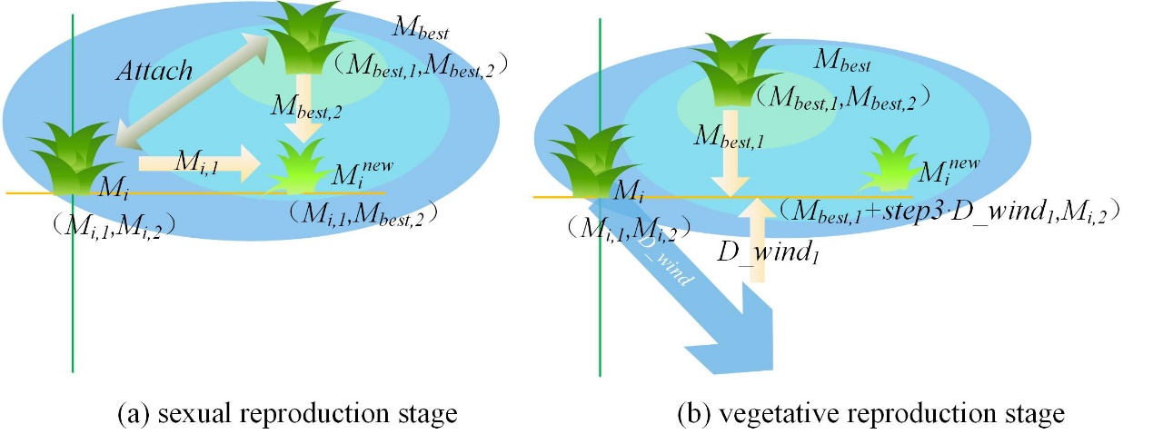
Figure 7. Search process of dual propagation search.

Cryptobiosis mechanism
This paper proposes a useful mechanism named the cryptobiosis mechanism to improve the greedy section mechanism. The phenomenon of cryptobiosis refers to the capability of moss to restore and flourish following a period of inactivity or aridity. Where moss confronts arid circumstances or loses its water supply, it desiccates and enters a state of metabolic dormancy. Once conditions become favorable, moss has the ability to revive.
Inspired by the phenomenon of cryptobiosis, this paper proposes a mechanism for recording the historical information of moss individuals. This method differs from the conventional method, in which individuals are directly altered. Instead, this mechanism keeps a record of the moss individuals produced in each iteration. Once certain conditions are met, such as reaching the maximum number of records (which is set to 10 in this paper) or concluding the population iteration, the mechanism is triggered to revive the optimal individual and replace the current one. On one hand, the cryptobiosis mechanism enables moss individuals to explore repeatedly from the same location, thus ensuring the ability of the entire population to explore globally. On the other hand, moss individuals can be replaced under certain conditions, thereby guaranteeing the population's quality.
The general process of cryptobiosis mechanism can be seen in Figure 8. For the i-th individual $M_{i}$ within the moss population, $M_{i}$ corresponds to the 0-th record. The remaining nine records are labeled as $rM_{i}^{e}$, where $e$ denote the $e$-th record of $M_{i}$. It is evident that the 7th record $rM_{i}^{7}$ obtains the optimal solution. This paper marks the best record as $rM_{i}^{best}$, then $M_{i}$ is modified to $rM_{i}^{best}$. The pseudo-code of the cryptobiosis mechanism is shown in Algorithm 1.
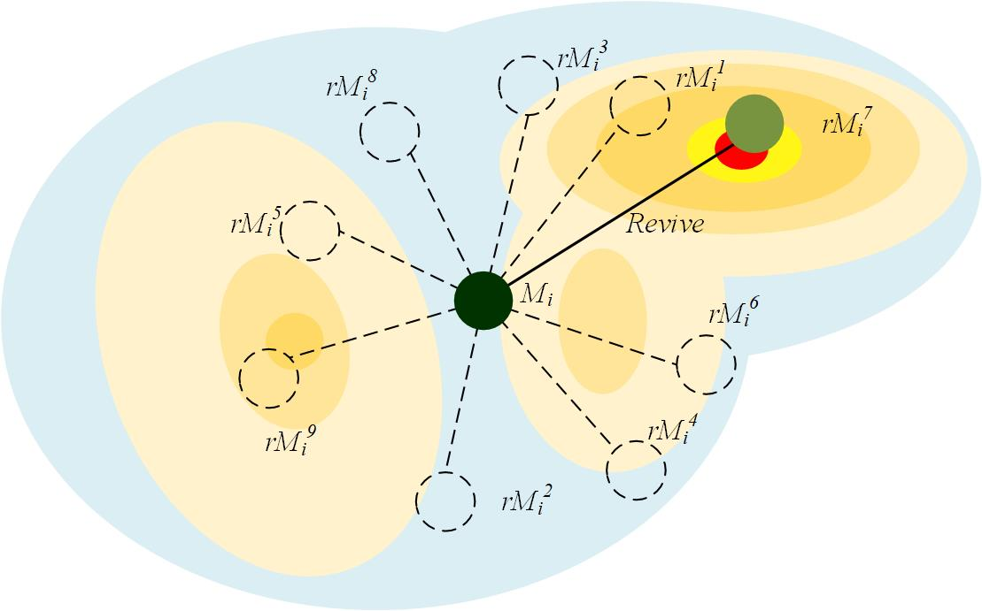
Figure 8. Process of cryptobiosis mechanism.

Algorithm 1: Pseudo-code of cryptobiosis mechanism
1. Input: $M_{i}$: i-th solution
${rec}_{num}$: maximum number of records
2. Output: Updated $M_{i}$
3. $record=0$
4. While ($FEs<MaxFEs$)
5. If $record=0$
6. $rM_{i}^{record}=M_{i}$
7. $record=record+1$
8. End if
9. Update the $M_{i}$
10. $rM_{i}^{record}=M_{i}$
11. $record=record+1$
12. If $record>ℜc_{num}−1∨t≥T$
13. $rM_{i}^{record}=M_{i}$
14. For $e=1:record$
15. If $Fitness\left(rM_{i}^{record}\right)<Fitness\left({rM}_{i}^{best}\right)$
16. ${rM}_{i}^{best}=rM_{i}^{record}$
17. End if
18. End for
19. $M_{i}=rM_{i}^{best}$
20. $record=0$
21. End if
22. $FEs=FEs+N$
23. End while
24. Return $M_{i}$

Proposed MGO algorithm
In summary, firstly, taking inspiration from the phenomenon governing the dispersal of moss spores through the wind, a mechanism employing two-stage search steps is put forward. This mechanism, named spore dispersal search, is subsequently utilized to conduct global exploration, serving as a fundamental optimization technique within the MGO. Then, drawing inspiration from the sexual and vegetative reproduction of moss, dual propagation search is introduced as another optimization method for the MGO. This mechanism enables effective searching around the optimal individual, which is advantageous for conducting local exploitation searches. Lastly, based on the phenomenon of cryptobiosis of moss, an improved greedy selection mechanism, named cryptobiosis mechanism, is proposed. This mechanism enables multiple explorations of the original individual, thus preventing the trap of local optima and simultaneously enhancing the population's quality.
The MGO algorithm begins by generating a set of random individuals. During each iteration, the population's evolution direction is determined based on determination of wind direction, followed by spore dispersal search. Dual propagation search is performed if $rand<0.8$, otherwise it is skipped. Individual solutions are updated according to the cryptobiosis mechanism. The overall structure of the algorithm in terms of flow chart and pseudo-code is shown in Figure 9 and Algorithm 2.

The time complexity of MGO
The complexity of MGO mainly includes initialization, fitness calculation, determination of wind direction, spore dispersal search, dual propagation search, and cryptobiosis mechanism. Among them, $N$ denotes the number of moss individuals, $D$ denotes the dimension of the individual, $T$ denotes the maximum number of iterations, and $R$ denotes the maximum number of records of cryptobiosis mechanism. The time complexity of initialization is $O\left(N\right)$. The time complexity of fitness calculation is $O\left(D\right)$. The time complexity of determining wind direction is $O\left(N×D/4\right)$. The time complexity of the spore dispersal search is $O\left(N×D\right)$. The time complexity of dual propagation search in the two cases is $O\left(N×D\right)$ and $O\left(N\right)$. The time complexity of the cryptobiosis mechanism is $O\left(N×R\right)$. Therefore, the overall time complexity of MGO is $O\left(T×N×\left(D+R+1\right)\right)$.
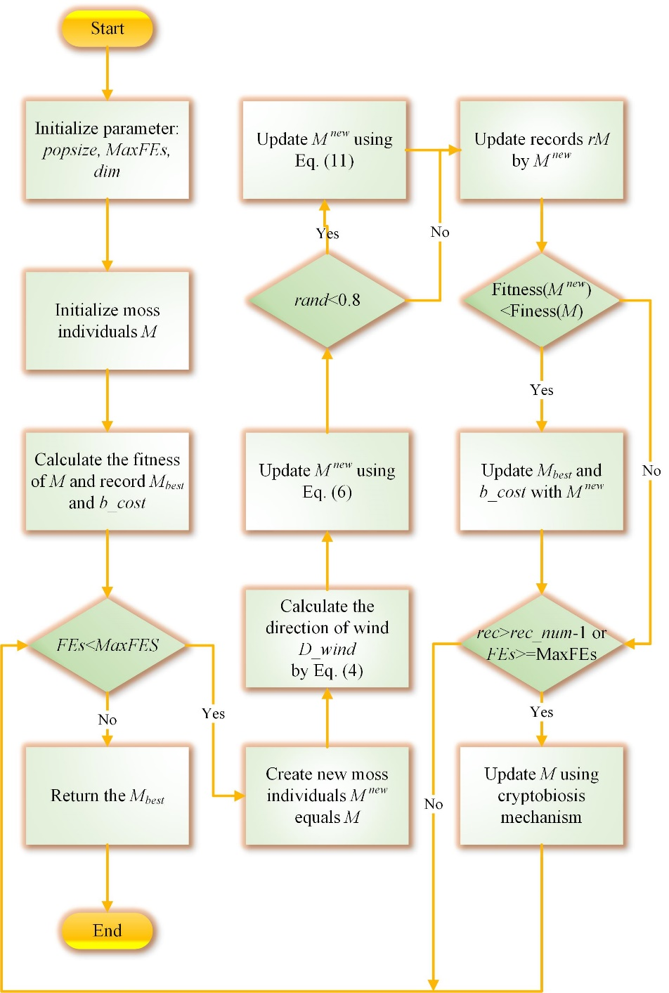
Figure 9. Flowchart of MGO.
Algorithm 2: Pseudo-code of MGO algorithm
- Input: $N$: population size
$dim$: the problem dimensions
2. Output: Optimal solution
3. Initialize a set of $M$
4. Calculate the fitness of $M$
5. Calculate the current optimal agent $M_{best}$ and optimal fitness $b_{cost}$
6. While ($FEs<MaxFEs$)
7. Calculate the wind direction $D_{wind}$ by Eq. (4)
8. For $i=1:N$
9. Create the new search agent $M_{i}^{best}$ equals $M_{i}$
10. Update the $M_{i}^{best}$ by Eq. (6)
11. If $rand<0.8$
12. Update $M_{i}^{new}$ by Eq. (11)
13. End if
14. If $Fitness\left(M_{i}^{new}\right)<Fitness\left(M_{best}\right)$
15. $M_{best}=M_{i}^{new}$
16. $b_{cost}=Fitness\left(M_{i}^{new}\right)$
17. End if
18. End for
19. For $i=1:N$
20. Update $M_{i}$ using the cryptobiosis mechanism
21. End for
22. $FEs=FEs+N$
23. End while
24. Return the best solution $M_{best}$

Pictures obtained from https://pixabay.com/ as copy right free images (a) https://pixabay.com/photos/moss-star-moss-forest-plant-2683009/ (b) https://pixabay.com/photos/moss-nature-brick-wall-illuminated-7342179/.

